create database Airline_Flight;

use Airline_Flight;

create table flights(

flno int primary key,

_from varchar(40),

_to varchar(40),

distance int,

departs time,

arrives time,

price int);

desc flights;

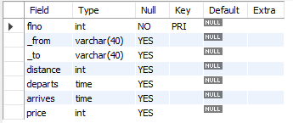

create table aircraft(

aid int primary key,

aname varchar(40),

cruising_range int

);

desc aircraft;

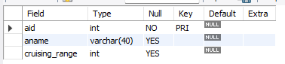

create table certified(

eid int,

aid int,

primary key(eid,aid),

foreign key(eid) references employees(eid) on delete cascade on update cascade,

foreign key(aid) references aircraft(aid) on delete cascade on update cascade

);

desc certified;

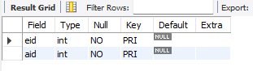

create table employees(

eid int primary key,

ename varchar(40),

salary int

);

desc employees;

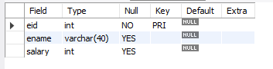

insert into flights

values(1,'Bengaluru','New Delhi',500,'6:00','9:00',5000),(2,'Bengaluru','Chennai',300,'7:00','8:30',3000),(3,'Trivandrum','New Delhi',800,'8:00','11:30',6000),(4,'Bengaluru','Frankfurt',10000,'6:00','23:30',50000),(5,'Kolkata','New Delhi',2400,'11:00','3:30',9000),(6,'Bengaluru','Frankfurt',8000,'9:00','23:00',40000);

select * from flights;

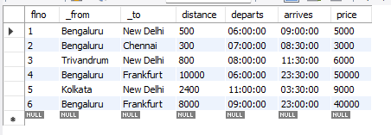

insert into aircraft

values(1,'Airbus',2000),(2,'Boeing',700),(3,'JetAirways',550),(4,'Indigo',5000),(5,'Boeing',4500),(6,'Airbus',2200);

select * from aircraft;

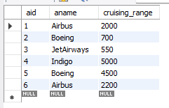

insert into certified

values(101,2),(101,4),(101,5),(101,6),(102,1),(102,3),(102,5),(103,2),(103,3),(103,5),(103,6),(104,6),(104,1),(104,3),(105,3);

select * from certified;

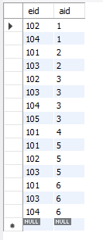

insert into employees

values(101,'Avinash',50000),(102,'Lokesh',60000),(103,'Rakesh',70000),(104,'Santhosh',82000),(105,'Tilak',5000);

select * from employees;

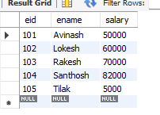

-- Todo 1

select A.aname from aircraft A,certified C,employees E where A.aid=C.aid and C.eid=E.eid and E.salary>80000;

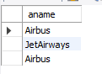

-- Todo 2

select E.eid,max(A.cruising_range) from employees E,aircraft A,certified C where A.aid=C.aid and C.eid=E.eid group by E.eid having count(C.aid)>=3;

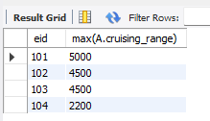

-- Todo 3

select ename from employees E where E.salary<(select min(price) from flights F where _from='Bengaluru' and _to='Frankfurt');

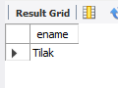

-- Todo 4

select A.aid,A.aname,avg(E.salary) from aircraft A,employees E,certified C where A.aid=C.aid and C.eid=E.eid and A.cruising_range>1000 group by A.aid;

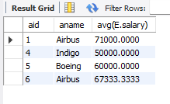

-- Todo 5

select distinct E.ename from employees E,certified C where C.eid=E.eid and E.eid in(select eid from certified where aid=some(select aid from aircraft where aname='Boeing'));

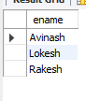

-- Todo 6

select A.aid from aircraft A,flights F where F.distance<A.cruising_range and F._from='Bengaluru' and F._to='New Delhi';

